Day 7 - 06th June 2025

Task001: Wap to display greetings

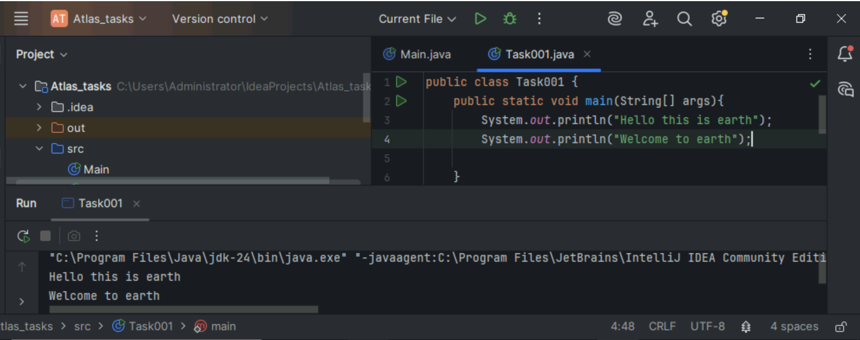

Task002: Wap to create a add method and call the method 3 times ..

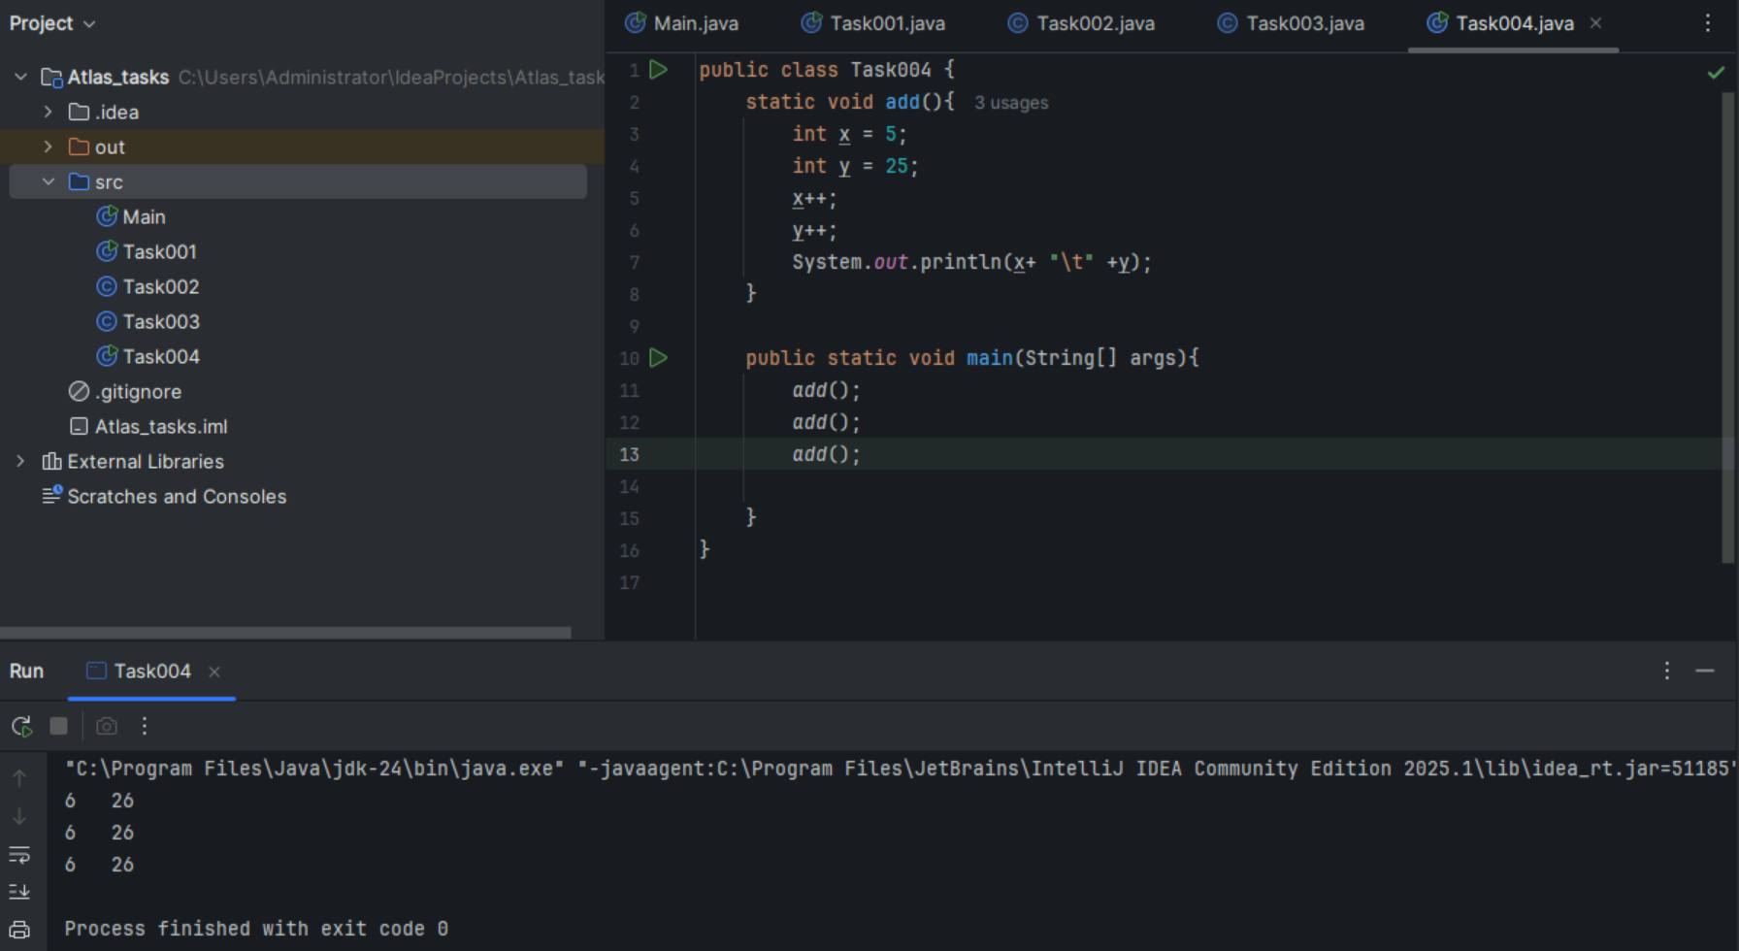

Task003 Write a Program in Java to Add two Numbers.

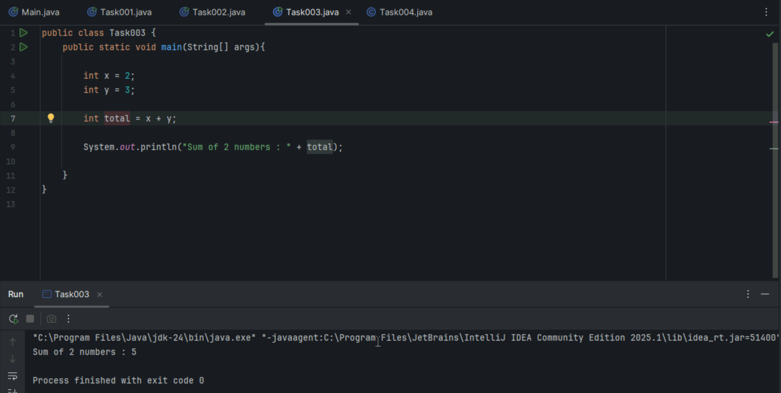

Input: 2 3

Output: 5

**Task004**: Write a Program to Swap Two Numbers

Input: a=2  b=5

Output: a=5  b=2

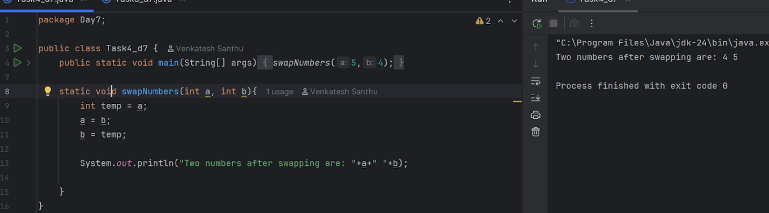

**Task005**: Create a code in which you have 4 methods add, subtract, multiply and divide (return type int) with a main [method..to](http://method..to) call all the other methods

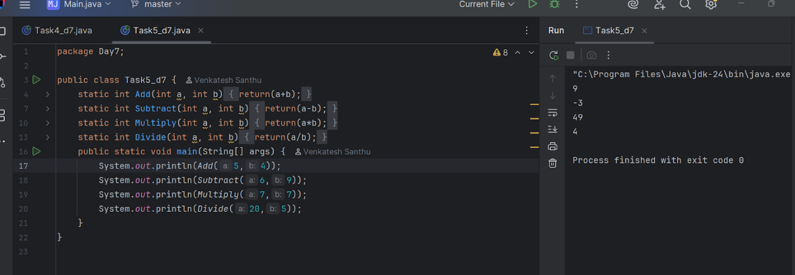

**Task006**: Write a program to check if a is greater or b.. Use ternary op

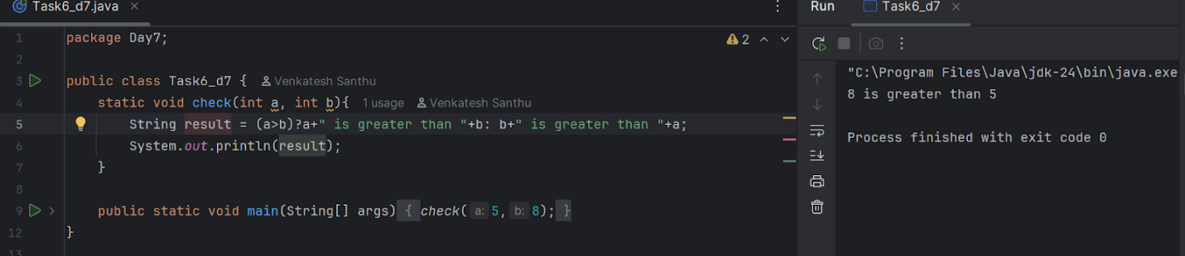

**Task007**: Write a program to take input from the user and display it to the user

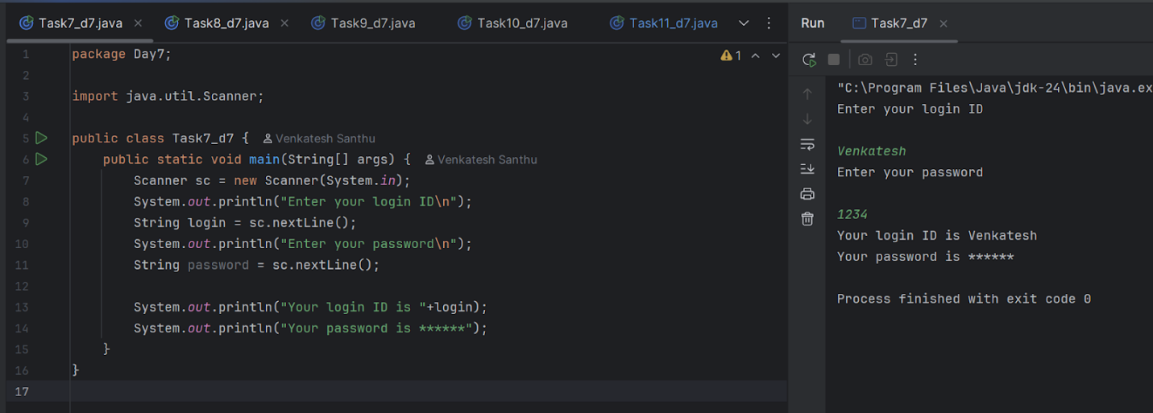

**Task008**: Write a program to create a class named Customer

Call the customer class in Task008 class using an object.

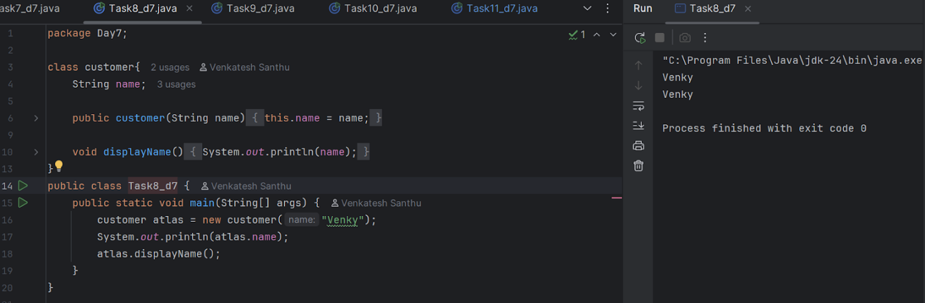

**Task009**: Wap to check the greater of 2 numbers

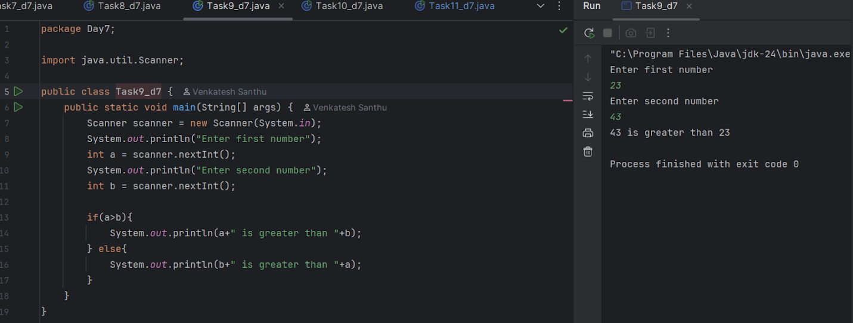

**task 010**: Wap to check greater of 3 numbers

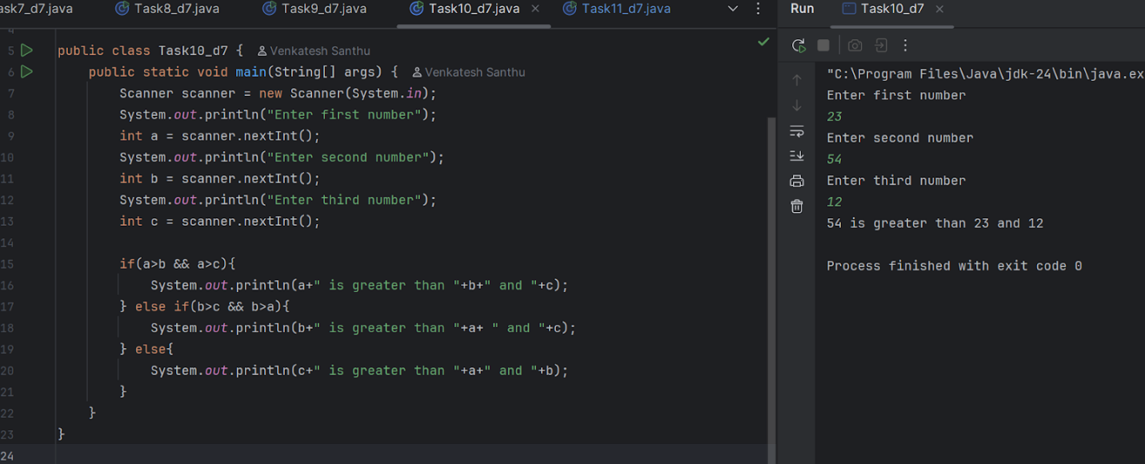

**Task11**: Wap to check if  week days

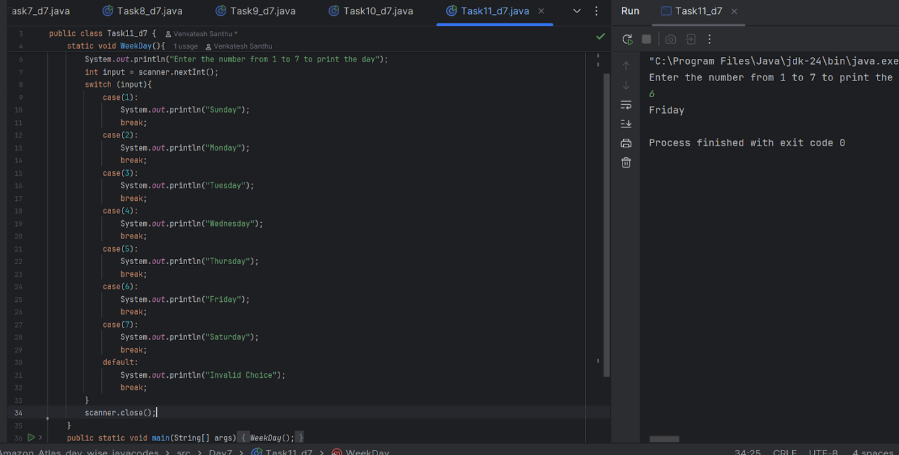

**Task 012**: Wap to check loginid and password validation

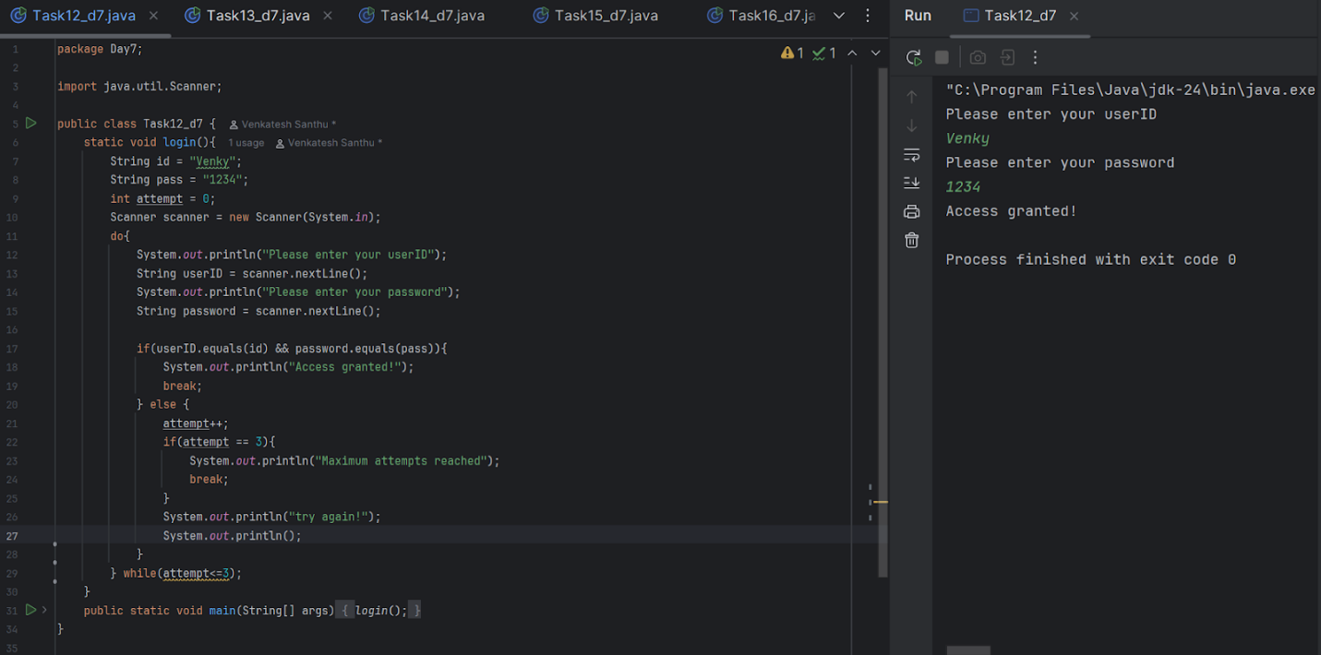

**Task 13**: Wap to display numbers from 10 to 1 .. skip 7 and 5.

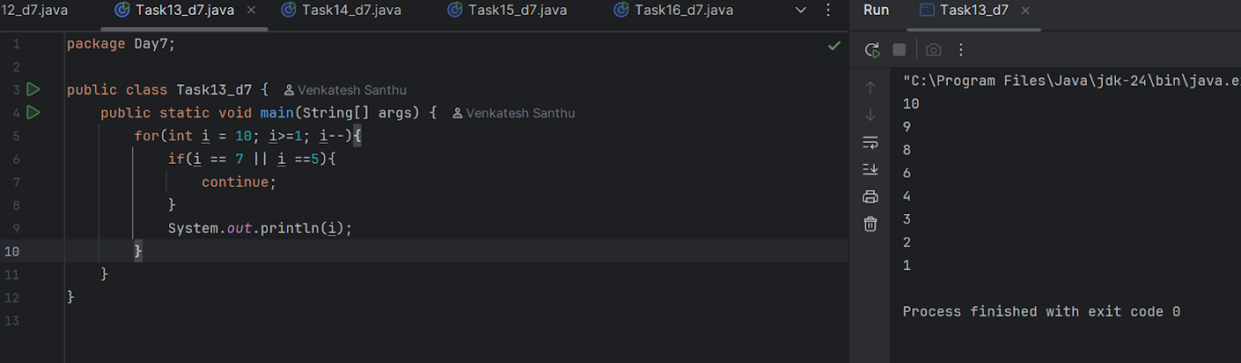

**Task 014**:

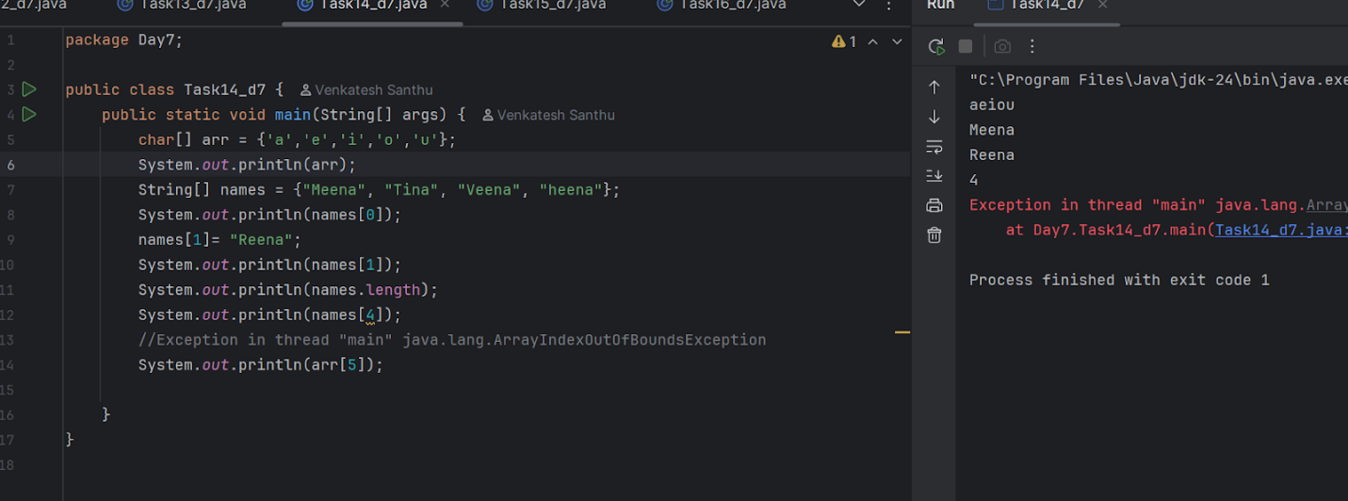

**Task 015**:

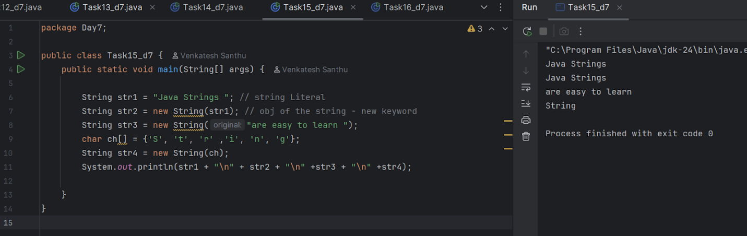

**Task 016:**

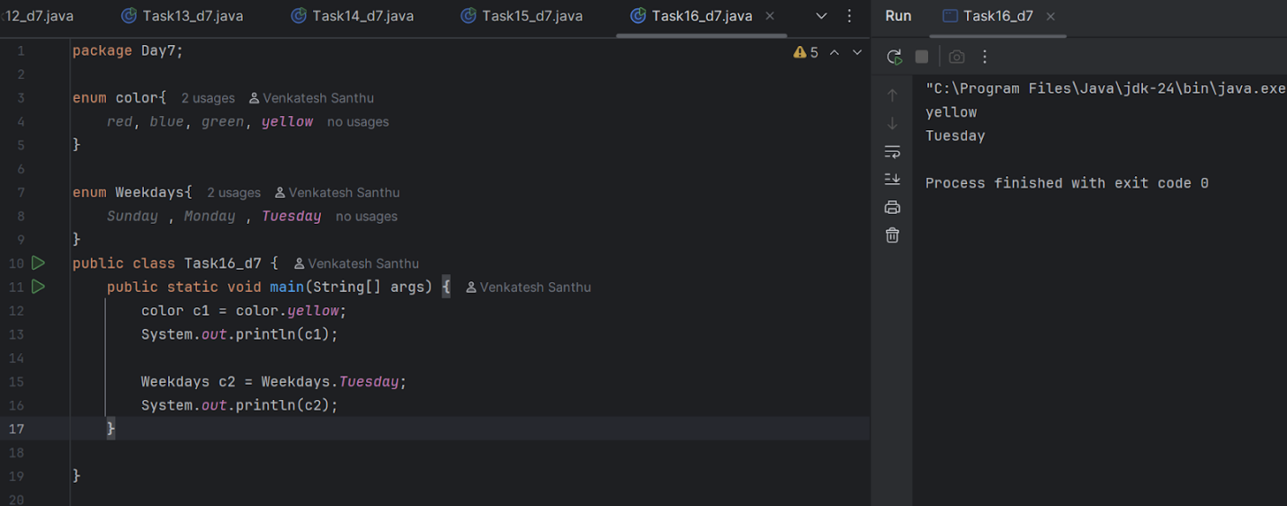

**Task 017**:

class Person {

   private String name;

   public String getName() {

       return name;

   }

   public void setName(String newName) {

       this.name = newName;

   }

}

public class Task017 {

   public static void main(String[] args) {

       Person myObj = new Person();

//        myObj.name = "John";

//        System.out.println(myObj.name);

       myObj.setName("Venky");

       System.*out*.println(myObj.getName());

   }

**Task 018:**

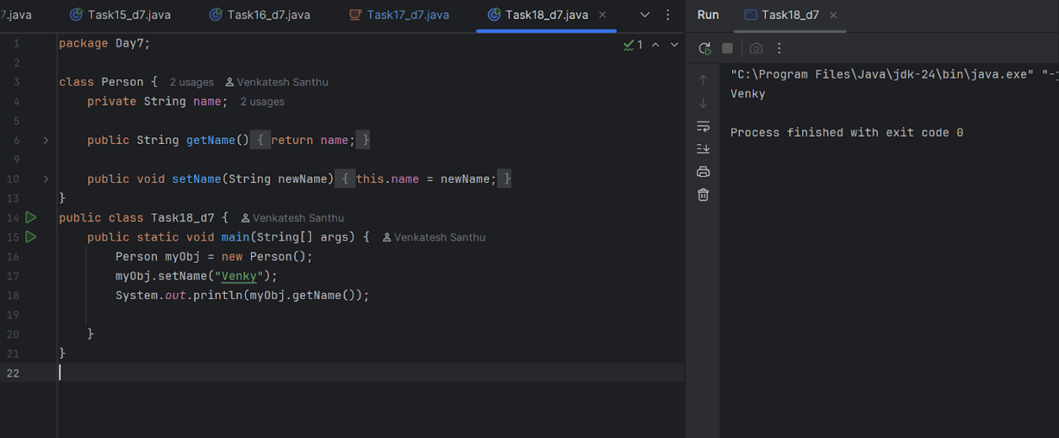

Task019.java

import java.util.HashMap;

import java.util.Map;

enum Element {

*H*("Hydrogen", 1, 1.008f),

*HE*("Helium", 2, 4.0026f),

*NE*("Neon", 10, 20.180f);

   private static final Map<String, Element> *BY_LABEL* = new HashMap<>();

   private static final Map<Integer, Element> *BY_ATOMIC_NUMBER* = new HashMap<>();

   private static final Map<Float, Element> *BY_ATOMIC_WEIGHT* = new HashMap<>();

   static {

       for (Element e : *values*()) {

*BY_LABEL*.put(e.label, e);

*BY_ATOMIC_NUMBER*.put(e.atomicNumber, e);

*BY_ATOMIC_WEIGHT*.put(e.atomicWeight, e);

       }

   }

   public final String label;

   public final int atomicNumber;

   public final float atomicWeight;

   private Element(String label, int atomicNumber, float atomicWeight) {

       this.label = label;

       this.atomicNumber = atomicNumber;

       this.atomicWeight = atomicWeight;

   }

   public static Element valueOfLabel(String label) {

       return *BY_LABEL*.get(label);

   }

   public static Element valueOfAtomicNumber(int number) {

       return *BY_ATOMIC_NUMBER*.get(number);

   }

   public static Element valueOfAtomicWeight(float weight) {

       return *BY_ATOMIC_WEIGHT*.get(weight);

   }

}

public class Task19_d7 {

   public static void main(String[] args) {

       Element element1 = Element.*valueOfLabel*("Hydrogen");

       System.*out*.println("Label: " + element1.label + ", Atomic Number: " + element1.atomicNumber + ", Atomic Weight: " + element1.atomicWeight);

       Element element2 = Element.*valueOfAtomicNumber*(2);

       System.*out*.println("Label: " + element2.label + ", Atomic Number: " + element2.atomicNumber + ", Atomic Weight: " + element2.atomicWeight);

       Element element3 = Element.*valueOfAtomicWeight*(20.180f);

       System.*out*.println("Label: " + element3.label + ", Atomic Number: " + element3.atomicNumber + ", Atomic Weight: " + element3.atomicWeight);

   }

}

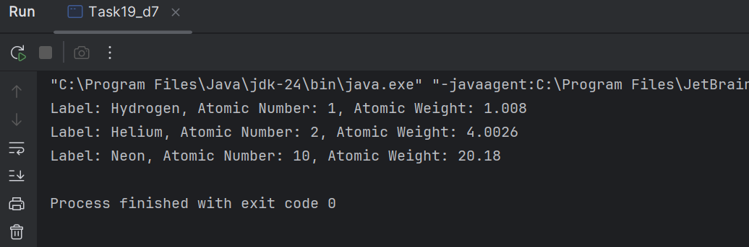

**Task 020**:

